Assignment 3

CIS 320

Trisia M Baltazar

Table of Contents

Use Case Diagram 2

Trace Matrix 2

Use Case: Add Summer Camp Application 3

Use Case: Modify Summer Application 5

Use Case: Delete Summer Camp Application 7

Use Case: View Summer Camp Application 8

Use Case: Register Summer Camp Application 9

Use Case: Add Summer Camp Event 11

Use Case: Modify Summer Camp Event 13

Use Case: Delete Summer Camp Event 15

Use Case: View Summer Camp Event 16

Prototypes 18

Add/ Modify Summer Camp Application 18

Delete Summer Camp Application 19

View Summer Camp Application 20

Register Summer Camp Application 21

Add/Modify Summer Camp Event 22

Delete Summer Camp Event 23

View Summer Camp Event 24

Class Diagram 25

# Use Case Diagram

The actor is depicted as the stick figures. An actor is a person that benefits and associates with a use case. The use cases are in the blue ovals. A use case is a sequence of actions. The actor and the use case are connected by an association line.

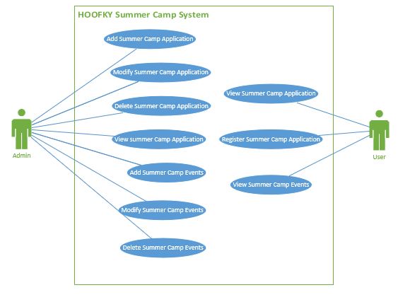

# Screen ClippingTrace Matrix

# Use Case: Add Summer Camp Application

|  |  |
| --- | --- |
| ID: | 11.A |
| Use Case Name: | Add Summer Camp Application |
| Primary Actor(s): | Admin |
| Risk Level: | Low |
| Description: | This use case describes how an admin can add a summer camp application form. |
| Precondition: | Admin is logged into WordPress and is in site editor. |
| Postcondition: | Summer camp application is available. |

|  |
| --- |
| Main Flow |
| * Admin creates Child’s first name textbox * Admin creates Child’s middle initial textbox * Admin creates Child’s last name textbox * Admin creates Child’s age textbox * Admin creates Child’s gender dropdown * Admin creates Child’s ethnicity textbox * Admin creates Parent’s first name textbox * Admin creates Parent’s last name textbox * Admin creates Parent’s middle initial textbox * Admin creates email textbox * Admin creates primary phone number textbox * Admin creates secondary phone number textbox * Admin creates emergency contact number textbox * Admin creates address line 1 textbox * Admin creates address line 2 textbox * Admin creates city textbox * Admin creates state textbox * Admin creates zip textbox * Admin creates summer camp month dropdown * Admin creates summer camp year dropdown * Admin creates summer camp name textbox * Admin creates summer camp history textbox * Admin creates agency textbox * Admin creates t-shirt size dropdown * Admin creates waiver checkbox * Admin saves changes * Admin requests submission to publish the application form * Summer application form is submitted * New application form is added onto hoofky * Admin logs off WordPress * Admin closes WordPress * Use case ends |

|  |
| --- |
| Main Flow |
| * Admin alters Child’s first name textbox * Admin alters Child’s middle initial textbox * Admin alters Child’s last name textbox * Admin alters Parent’s first name textbox * Admin alters Parent’s last name textbox * Admin alters Parent’s middle initial textbox * Admin alters email textbox * Admin alters primary phone number textbox * Admin alters secondary phone number textbox * Admin alters emergency contact number textbox * Admin alters address line 1 textbox * Admin alters address line 2 textbox * Admin alters city textbox * Admin alters state textbox * Admin alters zip textbox * Admin alters school name textbox * Admin saves changes * Admin requests submission to publish the application form * Summer application form is submitted * Modified application form is added onto hoofky * Admin logs off WordPress * Admin closes WordPress * Use case ends |

# Use Case: Modify Summer Application

|  |  |
| --- | --- |
| ID: | 11.B |
| Use Case Name: | Modify Summer Camp Application |
| Primary Actor(s): | Admin |
| Risk Level: | Low |
| Description: | This use case describes how an admin can modify a summer camp application form. |
| Precondition: | Admin is logged in WordPress and is in site editor. |
| Postcondition: | Summer camp application files are updated. |

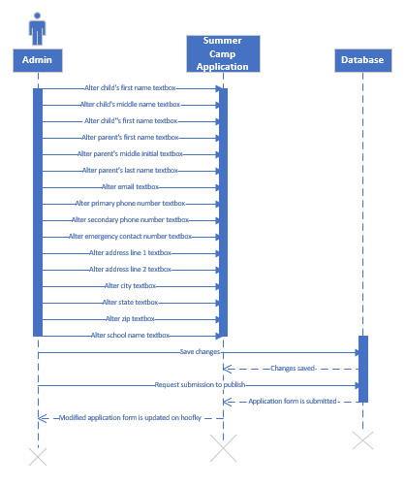

# 

# Use Case: Delete Summer Camp Application

|  |  |
| --- | --- |
| ID: | 11.C |
| Use Case Name: | Delete Summer Camp Application |
| Primary Actor(s): | Admin |
| Risk Level: | Low |
| Description: | This use case describes how an admin can delete a summer camp application. |
| Precondition: | Admin is logged in WordPress and is in site editor. |
| Postcondition: | Admin is logged in WordPress and is in site editor. |

|  |
| --- |
| Main Flow |
| * Admin requests delete link * Application is deleted * Admin saves changes * Admin requests submission to Publish * Summer application form is deleted on hoofky * Admin logs off WordPress * Admin closes WordPress * Use case ends |

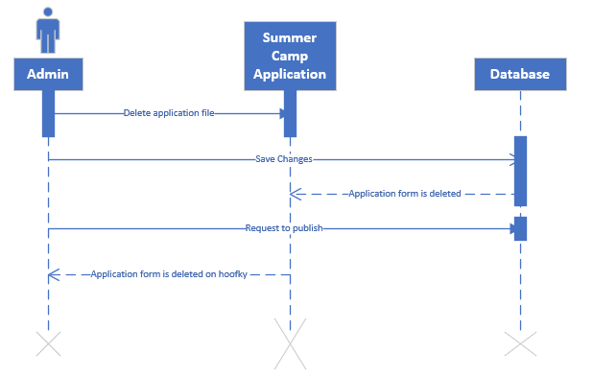

# Use Case: View Summer Camp Application

|  |  |
| --- | --- |
| ID: | 11.D |
| Use Case Name: | View Summer Camp Application |
| Primary Actor(s): | User |
| Risk Level: | Low |
| Description: | This use case describes how a user can view the summer camp application. |
| Precondition: | User is in hoofky.org |
| Postcondition: | User is able to view the summer camp application page. |

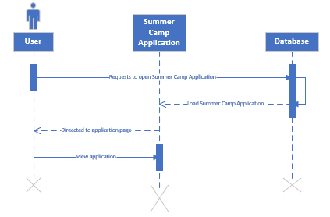

|  |
| --- |
| Main Flow |
| * User submits request on Summer Camp menu button * Summer Camp menu button shows drop down options * User clicks on Application * Summer Application loads * User directed to application page * User views Application * Use case ends |

# Use Case: Register Summer Camp Application

|  |  |
| --- | --- |
| ID: | 11.E |
| Use Case Name: | Register Summer Camp Application |
| Primary Actor(s): | User |
| Risk Level: | Low |
| Description: | This use case describes how a user can register for summer camp via application. |
| Precondition: | User is in hoofky.org |
| Postcondition: | User is registered for summer camp. |

|  |
| --- |
| Main Flow |
| * User request to open Summer Camp menu button * Summer Camp menu button shows drop down options * User clicks on Application * Summer Application loads * User directed to application page * User enters Child’s first name * User enters Child’s middle initial * User enters Child’s last name * User enter Child’s age * User enters Parent’s first name * User enters Parent’s last name * User enters Parent’s middle initial * User enters email textbox * User enters primary phone number * User enters secondary phone number * User enters emergency contact number * User enters address line 1 * User enters address line 2 * User enters city * User enters state * User enters zip * User enters school name * User saves changes * User requests submission * Summer application form is submitted * User gets notified that application is submitted * Use case ends |

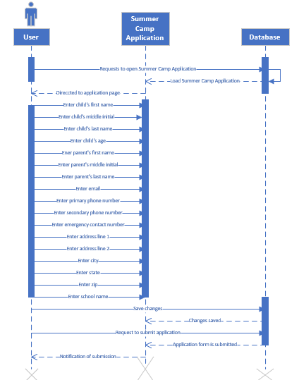

# Use Case: Add Summer Camp Event

|  |  |
| --- | --- |
| ID: | 12.A |
| Use Case Name: | Add Summer Camp Event |
| Primary Actor(s): | Admin |
| Risk Level: | Low |
| Description: | This use case describes how an admin can add a summer camp event. |
| Precondition: | Admin logged onto WordPress and has calendar plugin installed in site editor. |
| Postcondition: | Summer camp events are added onto the summer camp events page. |

|  |
| --- |
| Main Flow |
| * Admin enters title of the event * Admin enters address line 1 of the event * Admin enters address line 2 of the event * Admin enters city of the event * Admin enters state of the event * Admin enters zip code of the event * Admin enters start date of the event * Admin enters end date of the event * Admin enters start time of event * Admin enters end time of event * Admin enters description of event * Admin saves event * Admin adds event to upcoming events widget * Admin saves event on upcoming events widget * Admin adds event to mini calendar widget * Admin saves event to mini calendar widget * Admin requests to publish * Event is published on upcoming events on hoofky * Event is published on mini calendar on hoofky * Admin logs off WordPress. * Admin closes WordPress * Use case ends. |

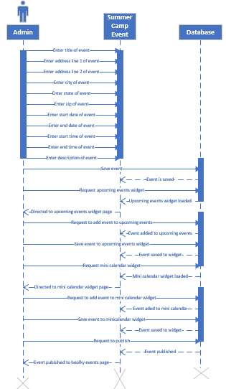

# Use Case: Modify Summer Camp Event

|  |  |
| --- | --- |
| ID: | 12.B |
| Use Case Name: | Modify Summer Camp Events |
| Primary Actor(s): | Admin |
| Risk Level: | Low |
| Description: | This use case describes how an admin can modify a summer camp event. |
| Precondition: | Admin logged onto WordPress and has calendar plugin installed in site editor. |
| Postcondition: | An existing summer camp application is updated. |

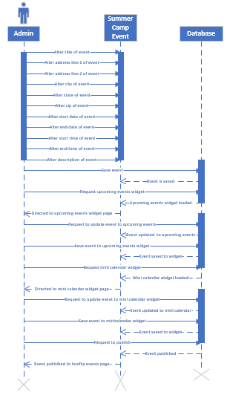

|  |
| --- |
| Main Flow |
| * Admin selects an existing summer camp event. * Admin alters title of the event * Admin alters address line 1 of the event * Admin alters address line 2 of the event * Admin alters city of the event * Admin alters state of the event * Admin alters zip code of the event * Admin alters start date of the event * Admin alters end date of the event * Admin alters start time of event * Admin alters end time of event * Admin alters description of event * Admin saves altered event * Admin saves altered event on upcoming events widget * Admin saves altered event to mini calendar widget * Admin requests to publish * Event is published on upcoming events on hoofky * Event is published on mini calendar on hoofky * Admin logs off WordPress. * Admin closes WordPress * Use case ends. |

# Use Case: Delete Summer Camp Event

|  |  |
| --- | --- |
| ID: | 12.C |
| Use Case Name: | Delete Summer Camp Events |
| Primary Actor(s): | Admin |
| Risk Level: | Low |
| Description: | This use case describes how an admin can delete a summer camp event. |
| Precondition: | Admin logged onto WordPress and is in site editor. |
| Postcondition: | An existing summer camp event is deleted. |

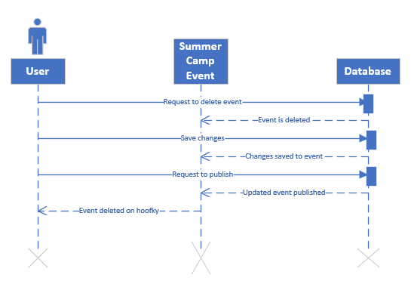

|  |
| --- |
| Main Flow |
| * Admin deletes event * Admin saves changes * Summer event is deleted. * Admin requests to Publish * Summer camp event is deleted on hoofky * Admin logs off WordPress * Admin closes WordPress * Use case ends |

# Use Case: View Summer Camp Event

|  |  |
| --- | --- |
| ID: | 12.D |
| Use Case Name: | View Summer Camp Events |
| Primary Actor(s): | User |
| Risk Level: | Low |
| Description: | This use case describes how a user can view summer camp events. |
| Precondition: | User is in hoofky.org |
| Postcondition: | User views summer camp events. |

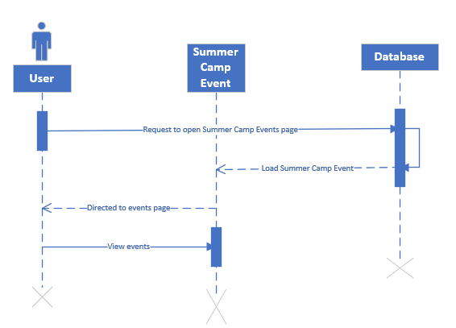

|  |
| --- |
| Main Flow |
| * User hovers over Summer Camp menu button * Summer Camp menu button shows drop down options * User request to enter Events page * Summer camp event loads onto user screen * User views events * Use case ends |

# Prototypes

## Add/ Modify Camper Record

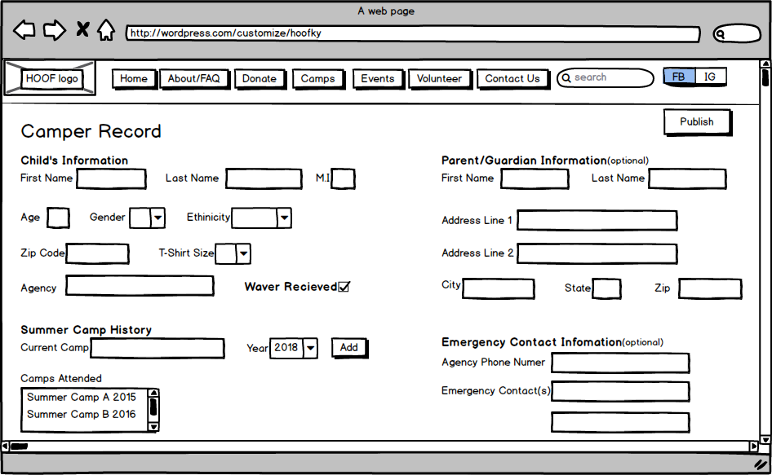

## Delete Camper Record

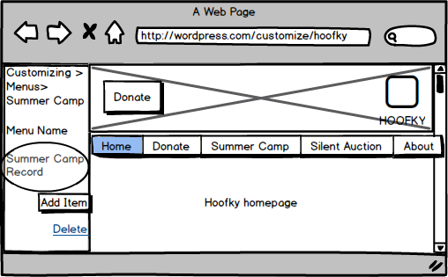

## View Summer Camp Application

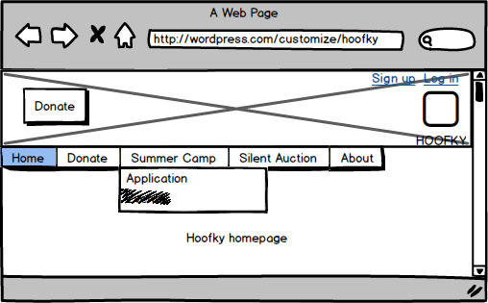

## Register Summer Camp Application

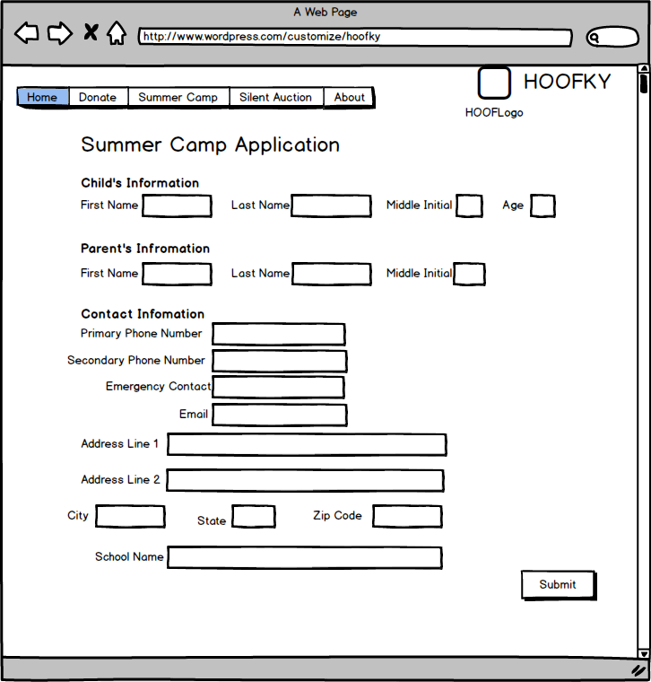

## Add/Modify Summer Camp Event

C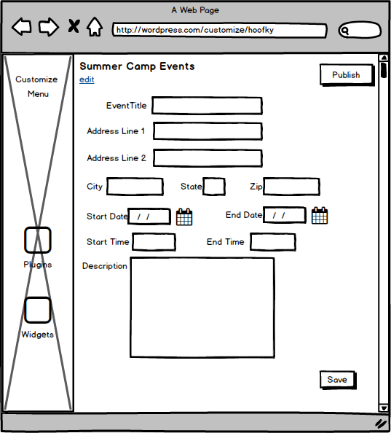

## Delete Summer Camp Event

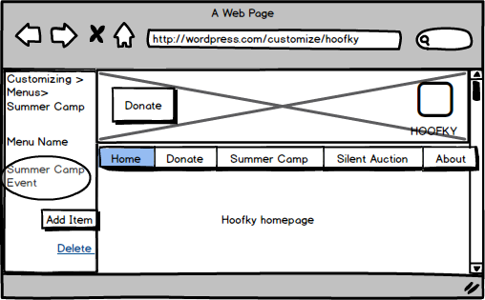

## View Summer Camp Event

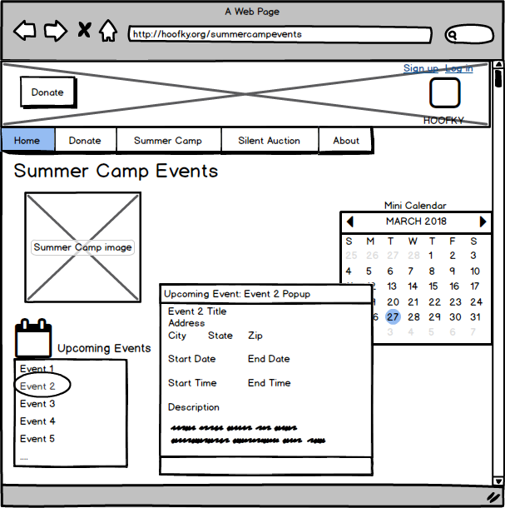

# Class Diagram

This is the class diagram for the summer camp classes. It shows how the user and admin connect to the summer camp application and events, and how the application and the events connect to the user and the admin. Methods are the actions the class makes and attributes are values that are attached to the class. Overall, the diagram shows the relationship between each class and the overview of the system.

